<AI Fitness Equipment>
Group: <59>
EBU5606 Product Development and Marketing
Group Members:
<Tangxun Wu, 200978947, 2020213248 >
<Wenxi Han, 200977283, 2020213246 >
<Ruiqiao Yang, 200979287, 2020213249 >
<Yurong He, 200977331, 2020213242 >
<Zihe Wei, 200978866, 2020213281>
Report Word Count: 3610

Table of Contents
Summary of Responsibilities 3
Individual Member 1 (Group Leader) Contribution: <Tangxun Wu> 3
Individual Member 2 Contribution: <Wenxi Han> 3
Individual Member 3 Contribution: <Ruiqiao Yang> 3
Individual Member 4 Contribution: <Yurong He> 3
Individual Member 5 Contribution: <Zihe Wei> 3
Introduction 4
Opportunity Identification 5
Mission Statement 10
Identification of Customer Needs 11
Concept Generation and Testing 17
Conclusion 26
List of References 27
Coursework Meeting Logbook 28

Summary of Responsibilities

Individual Member 1 (Group Leader) Contribution: <Tangxun Wu>
She summarized the whole article.
She accomplished “generate & sense many opportunities” in “opportunity identification” section(p5).
She summarized “mission statement” section(p10).
She completed “Interpret raw data in terms of customer needs” and “Establish the relative importance of the needs” in “identify customer needs” section(p11).
She completed “explore systematically” in “concept generation and testing” section(p17).
She wrote findings in “conclusion” section(p26).

Individual Member 2 Contribution: <Wenxi Han>
She scratched the prototype of the product in “concept generation and testing” section(p17).
She made and analyzed the questionnaire of customer needs in “identify customer needs” section(p11).
She did the customer interviews in “identify customer needs” section(p11).
She analyzed the part of problem decomposition in “concept generation and testing” section(p17).
She wrote the potentials and shortcomings in “conclusion” section(p26).

Individual Member 3 Contribution: <Ruiqiao Yang>
She interpreted raw data in terms of customer needs in “identify customer needs” section(p11).
She wrote the “REAL-WIN-WORTH-it” charts to select a few that were most worthy of investment in “identify customer needs” section(p11).
She searched for the names of materials that could be used for safe fluoroscopy and the technology that could be used for body monitoring and collected sources in “concept generation and testing” section(p17).
She drew the questionnaire and analyzed it in “concept generation and testing” section(p17).
She chose a survey format and measured customer response in “concept generation and testing” section(p17).

Individual Member 4 Contribution: <Yurong He>
She reflected on the results and the process after identifying customer needs in “identify customer needs” section(p11).
She wrote the concept generation and reflected on results after identifying the opportunities in “opportunity identification” section(p5).
She wrote the assumption of the product and the critical sub-problems in “concept generation and testing” section(p17).
She reflected on the results and the process in “concept generation and testing” section(p17).

Individual Member 5 Contribution: <Zihe Wei>
She organized the customers’ need into hierarchy in “identify customer needs” section(p11).
She established the charter and screened the opportunities in “opportunity identification” section(p5).
She summarized technologies that were related to personalized recommendations and connected products to external devices in “concept generation and testing” section(p17).
She wrote the first two steps of testing in “concept generation and testing” section(p17).

Introduction

This article is aimed at developing an AI fitness equipment which can read one's physical indicators while exercising, correct personal posture, provide professional guidance and allow live update interaction. To finish this article, we had deep discussions and used ways of interviews and questionnaires in order to fully understand tasks and needs. After completing stages of opportunity identification, mission statement, identification of customer needs, concept generation and testing and so on, our group confirmed the concept of product, finding potentials and shortcomings of this product.

Opportunity Identification

Step 1: Establish a charter
Considering the strengths of our company in all aspects, we set a charter that articulated our goals and boundary conditions for an innovation effort.
Charter: Create a technology product that focuses on human health and can be launched within one year based on our company's marketing strategy nowadays.

Step 2: Generate and sense many opportunities
We focused on both internal and external sources to generate raw opportunities which were suitable for our company.
Internal:
Our R&D department has developed “Motion-sensing Technology”, which can be applied to detect users’ body conditions. Besides, with the popularization of 5G and big data, it was not only easy for our company to fasten the speed of stable network connection, but also convenient to collect users’ data so as to establish individualized functions.
External:
From the current customers, we learned that they had more demanding for health products because of the pandemic. Then, with the population aging, more elder people meant more needs for diet guidance, so as to deal with the health problem. Besides, many young people who enjoyed advantages brought by technology hoped our company to promote an innovative AI product, which could be beneficial to fitness and alleviate sports injury.
As for other partner companies, we had many cooperation projects with them. With the long-time relationship, our company enjoyed more opportunities. Firstly, we could update our new products on Taobao and JD to promote sales. Secondly, SF Express could provide logistics support for us to ensure the delivery of our products. Last but not least, we could cooperate with the Keep app, which was one of the most popular exercise apps in China, to invite many experts and professional coaches.
From the above resources, we generated the 4 raw opportunities:
1. Establish a nutritional diet app, use big data to recommend healthy recipes to users and provide delivery services.
2. Build a smart court, and use motion sensing to guide users’ actions in the actual court.
3. Develop an indoor fitness equipment, hire professional trainers and utilize motion sensing technology to allow users to exercise indoors.
4. Develop a smartwatch that monitors the users’ heart rate and sleep quality.

Step 3: Screen opportunities
Faced with the four raw opportunities, we held a meeting to discuss and vote to choose the products that were more competitive, more worthy of further investigation and more likely to be profitable. In this step we eliminated the opportunity of developing a smartwatch.
The result of multi-voting is as follows:
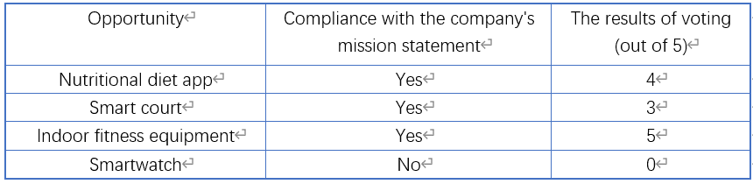
Figure 1. The result of multi-voting

Step 4: Develop promising opportunities
In this step, we sought more details about the rest of three opportunities, in order to resolve the greatest uncertainty surrounding each opportunity at the lowest cost in time and money. Our group chose to utilize methods of “Concept generation” and “Customer interviews” to select a few of screened opportunities, which are shown below.
Concept generation
1. A nutritional diet app: an APP that uses big data to provide users with healthy recipes and help them properly adjust their diet.
2. A smart court: an APP that can use the motion sensing function to analyze the users’ playing movements in the court, provide professional guidance. Besides, it has social interaction function, which can help users to invite nearby users to play together.
3. An indoor fitness equipment: an AI fitness equipment which can read one's physical indicators while exercising, correct personal posture, provide professional guidance and allow live update interaction.
Customer interviews
In order to make our products have better development prospects, we interviewed people around us as well as some experts. They provided lots of unique insights, which were crucial to our final decisions.
When we interviewed our parents, they said they didn't appreciate the function of nutritious meals because they were used to cooking in their own way and didn't trust new combinations of food which were provided by technologies.
At the same time, my classmates said that there were already a lot of ready-made diet collocation recommendations on some social applications. If we invented similar functions of the product, it may be highly overlap.
Finally, we consulted our teachers in the school. They said that if a product only had the function of recommending nutritious diets, it was too simple and had poor development prospect in the constantly changing market. It was not convenient to cooperate with other companies, too.
After reviewing the above interviews, we decided not to develop a product related to the nutritional diet field.

Step 5: Select exceptional opportunities
In this part, we used “Real-Win-Worth-it” to select the opportunity that was most worthy of investment. The following charts show the RWW criteria applied to the “an AI fitness equipment” opportunity. In this step we selected an exceptional product opportunity: Develop an indoor AI fitness equipment.
1. Is the opportunity real?
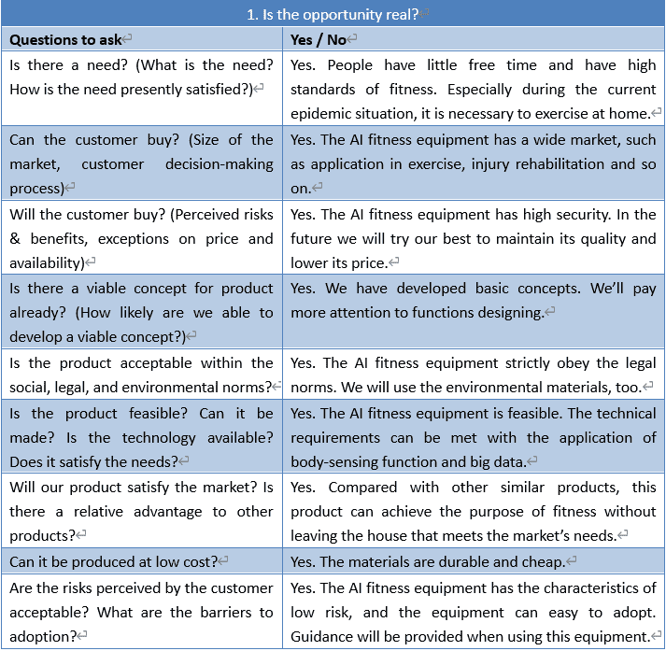
Figure 2. Q&A about "Is the opportunity real?"
2. Can you win with this opportunity?
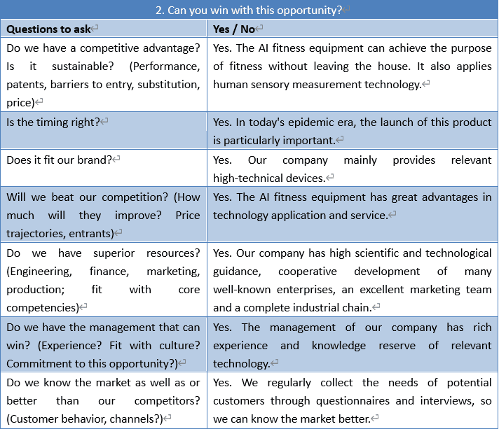
Figure 3. Q&A about "Can you win with this opportunity?"
3. Is it worth doing?
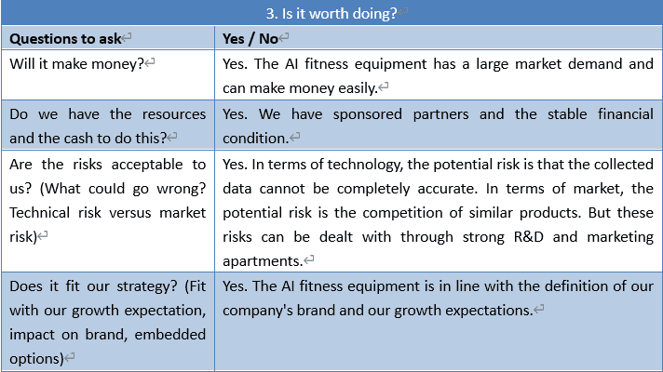
Figure 4. Q&A about "Is it worth doing?"

Step 6: Reflect on the result and process
Timely reflection can not only let us know the existing problems, but also help us improve the work efficiency in the next stage.
After reflection, we found that the opportunities were viable. First, our team considered dozens of opportunities from internal and external sources. Second, the innovation charter clearly stated the purpose of the organization. The charter’s focus was not narrow, so we had more opportunities than we expected. Third, our filtering criteria were objective. They were based on the possibility that the eventual product would be produced successfully.
Therefore, the resulting opportunities were exciting to our team and satisfied the whole team’s expectations.

Mission Statement

Product Description
- An AI fitness equipment which can read one's physical indicators while exercising, correct personal posture, provide professional guidance and allow live update interaction.

Key Business Goals
- 1 million units of the products will be sold worldwide by 2025
- Serve as fitness equipment for all future public gyms
- Energy conservation
- Capture 40% of digital exercise equipment sales in primary market

Primary Market
- Household use
- Amateur fitness enthusiasts

Secondary Markets
- Public fitness venues such as for-profit gyms
- Fitness professionals

Assumptions and Constraints
- The whole supply chain is completed in China
- Human Sensory Measurement technology
- Compatible with IOS, Android and Harmony OS systems
- Supporting 5G network ports to have real-time interaction
- With external hardware configuration, such as smart wristband

Stakeholders
- Purchasers
- Consultants
- Manufacturing Operations
- Retailers
- Service Operations
- Legal Department

Identification of Customer Needs

Step1：Gather raw data
To gather raw data, our team chose to start with finding secondary data from some applications in smartphones. They sold existing fitness equipment so that we could find feedbacks from buyers. The reason why we did it first was that: Not only was it easier to obtain, but also it could form a basis for better designing the method of collecting primary data, so as to excavate more effective customers’ needs.
After we finished collecting secondary data, we divided types of needs into six aspects—product appearance, social interaction function, combining innovative technologies, participation of professional experts, user-friendly interface and multiple connections with external equipment. These helped us to stimulate customers’ needs in terms of “what the product has to do, not how it might do”.
However, since the spread of the COVID-19, to collect the primary data, our team finally used one of the methodologies called surveys, which were via web-based questionnaires to make connection with potential customers.
We distributed 100 pieces of questionnaires to people who had some interest in exercising indoors. By using the basis formed by collected secondary data, we provided many choices for interviewees, rather than just let them use imagination to answer. Finally, 96 feedbacks were received. The feasibility of our products was checked, too.
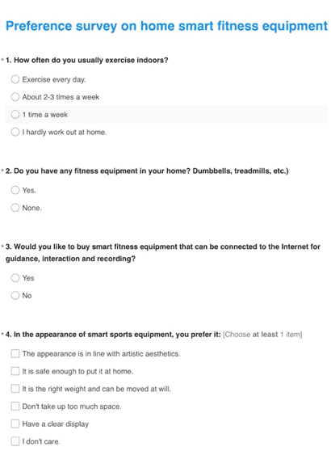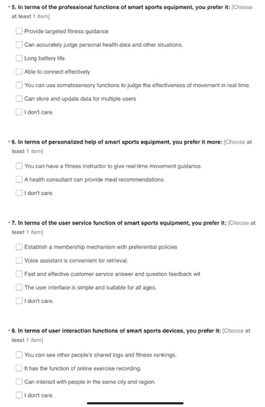
Figure 5. Choices on the questionnaire
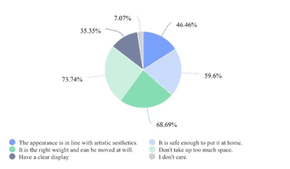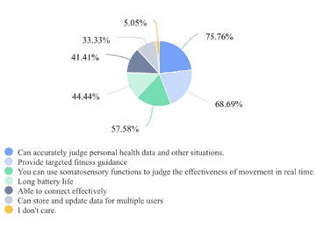
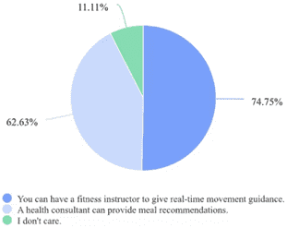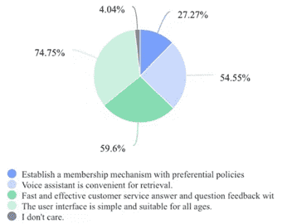
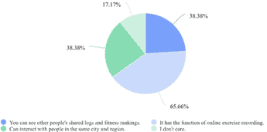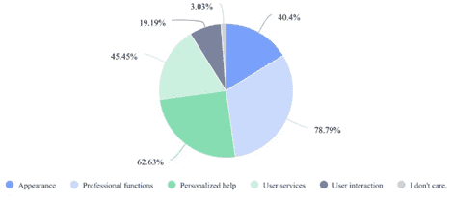
Figure 6. Results on the questionnaire

Step2: Interpret raw data in terms of customer needs
In the previous step, we got a number of responses about needs from potential customers. Therefore, in this step, we committed ourselves to interpreting needs as attributes of our product. Besides, we changed all statements into positive phrasing. Some transformation we did between needs and attributes are attached as follows:
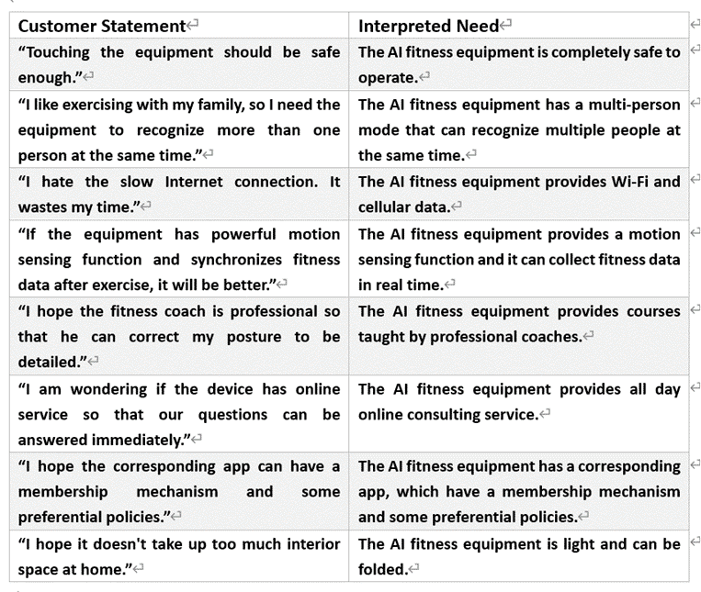
Figure 7. Interpret raw data in terms of customer needs

Step3: Organize the needs into a hierarchy
In this step, we structured the needs into four groups, which were showed as the following figure. After we did this classification, we could better design our products in the order of importance and hierarchy.
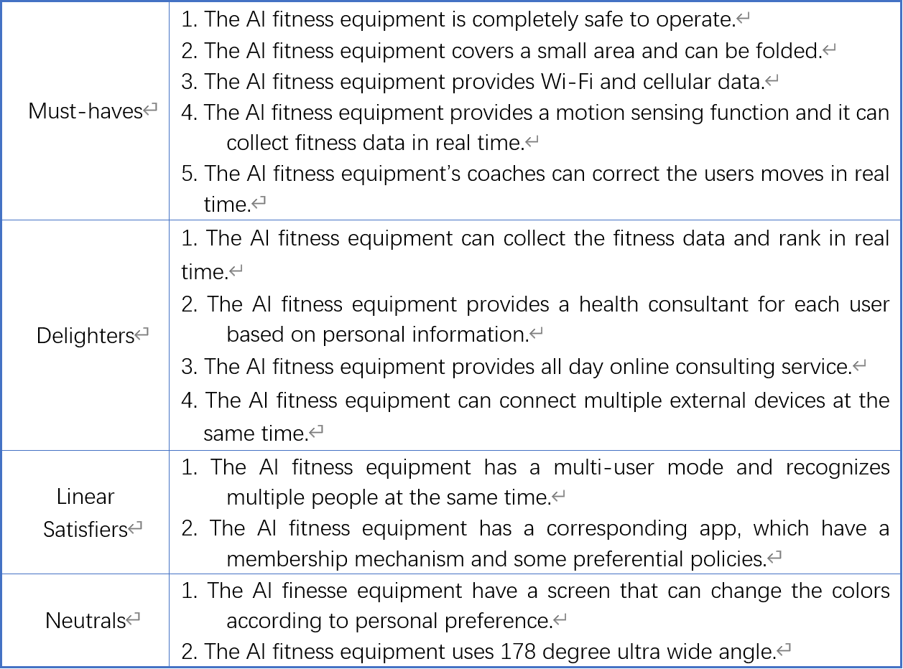
Figure 8. Organize the needs into a hierarchy

Step 4: Establish the relative importance of the needs
We did a survey in order to measure consumers’ preferences, so as to establish the relative importance of the needs. This definitely helped our organization build product concepts, as well as the manufacturing process.
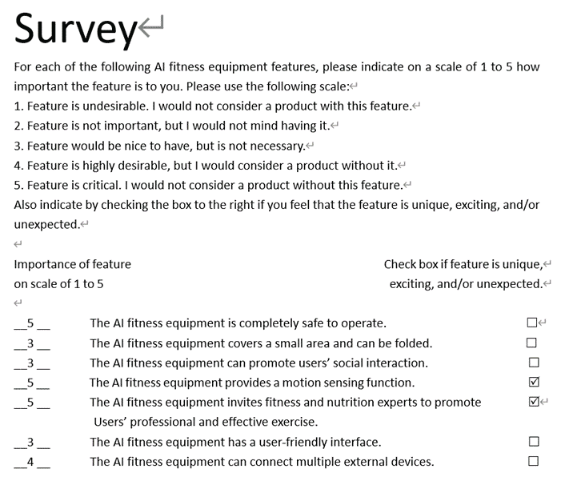
Figure 9. Surveys to establish the relative importance of the needs

Step 5: Reflect on the results and the process
In the real product development, it was impossible for us to complete every step perfectly, so the timely reflection after the investigation was necessary. We reflected the above process by asking the questions as follows:
1. Have we interacted with all important customers in our target market?
Yes. Our primary market was for household use. And the people who filled in the questionnaires were all amateur fitness enthusiasts. We asked them what functions they expected about this product and got responses quickly.
2. Can we see the latent needs of customers beyond our current product range?
Yes. Through the survey, we could find that people had a high demand for high-edge technology combination and social interaction function. These were the latent needs. However, the current product range couldn’t satisfy those requirements completely.
3. Can we further involve any of the customers in our product development?
Yes. On one hand, we could issue questionnaires in the early stage of product development to get suggestions for improvement. On the other hand, we could set up a feedback mechanism on the APP.
4. Did we involve the right people in our organization?
Yes. Our team members were good at sales, R&D and other aspects. We were responsible and ensured that everyone who needed to learn about customer needs were involved.
5. Can we improve our process?
Yes. After our reflection, we found that we could improve our process by increasing the way of the investigation. For example, we could have regular interviews to focus on our target customers.

The whole organized list of customer needs:
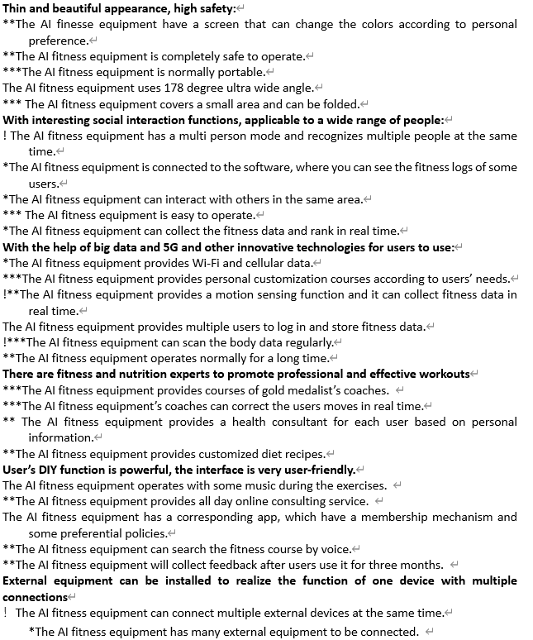
Figure 10. An organized list of customer needs

Who and what customers are or could be interested in this product?
Our products mainly attract those amateur fitness people who have fitness hobbies, trust technology, and usually don’t have time to go to the gym.
Besides, our products may appeal to patients who want to take advantage of this product for rehabilitation and expect to enjoy the care services provided by a nutrition expert.
In addition, the product can be invested for commercial use, such as company use, which combine work with relaxation into just one place.
Finally, fitness professionals can use the product to do their own fitness routines, so as to promote themselves.

Concept Generation and Testing

Concept Generation
In this part, we generated the concepts of our product, and developed a prototype using drawings below to show functions and application scenarios.
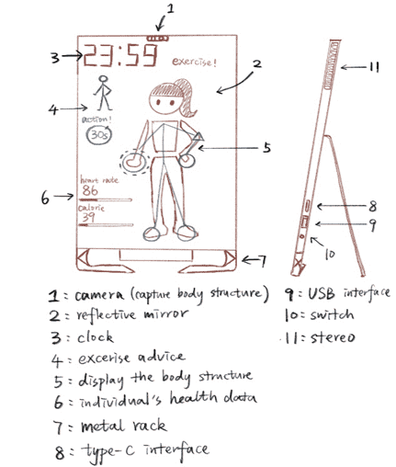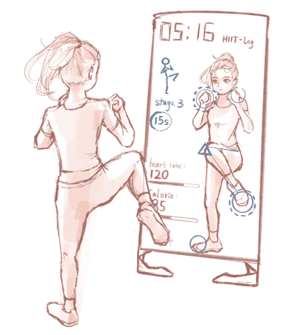
Figure 11. Drawings about our product’s concept
The Steps for generating concepts are as follows:

Step1: Clarify the problem
1. Understanding the problems
a) The product is exquisite in shape and portable in size.
b) The product can use the body sensory function to monitor human data.
c) The product allows users to interact socially.
d) The product has the function of personalized customization for users.
e) The product can connect to external devices through external connections.
2. Problem decomposition
In this part, we divided the problems mentioned above given their different technology application fields, so as to find out critical sub-problems exactly later. The figure below indicates the results of problem decomposition:
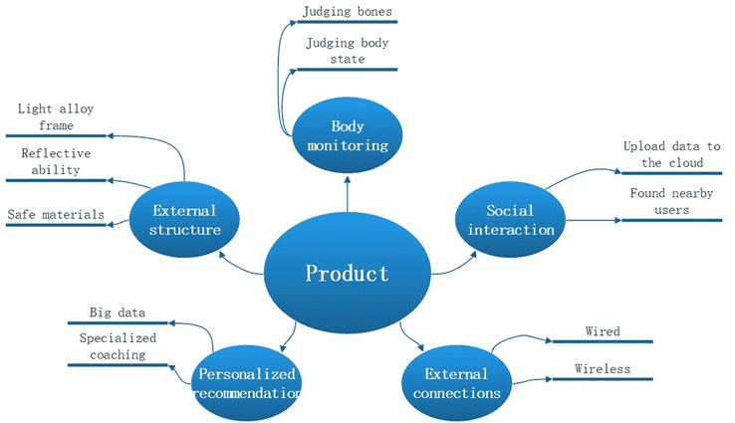
Figure 12. Decomposition about problems
3. Focus on critical sub-problems
We believed that the following problems were the product’s technical cores which had decisive impacts on the user experience: 1. Equipment materials 2. Body monitoring 3. Personalized customization 4. External connections

Step2: Search externally
In this step, external data were obtained by searching literature, finding patents and looking for lead users' comments on the existing concepts of designs and technologies.
1. Lead users
Equipment materials：
a) Aluminum alloy support frame, whose surface is solid and weight is light;
b) IPS (In-panel Switching) screen combined with cameras, which is wide and clear;
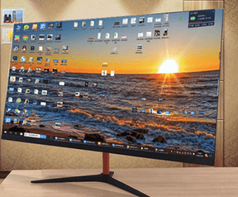
Figure 13. Picture which describes In-panel Switching screen
2. Literature
Personalized customization:
a) A system using Spark streaming, HBase, MySQL and Hive.
The system can rearrange multiple recall sources such as collaborative filtering, similar courses and popularity according to users' real-time preferences to generate real-time recommendation results (Li, 2021).
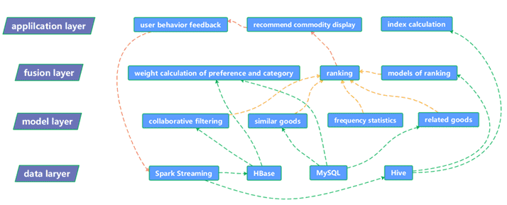
Figure 14. Picture which describes one personalized customization system
External connections:
a) Bluetooth technology, which is the fusion of wireless communication and data communication. The technology is based on low-cost, near-field wireless connections that can set up communication environments for both fixed and mobile devices (Li & Zhao, 2001).
b) USB interface, which is an external bus standard used to regulate the connection and communication between computers and external devices.
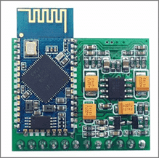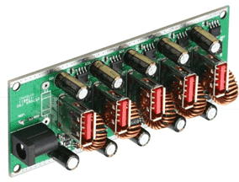
Figure 15. Inner structures about Bluetooth technology(left) and USB interface(right)
3. Patents
Body monitoring:
a) NPU neural network recognition technology
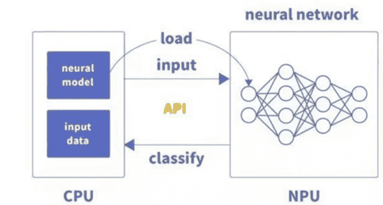
Figure 16. Working theorem of NPU neural network recognition technology
b) Intelligent interactive knowledge system
c) Intelligent sensor
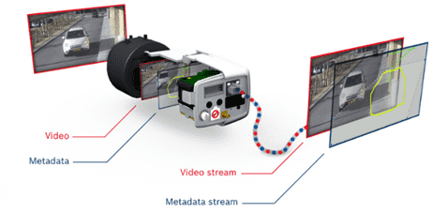
Figure 17. Working theorem of Intelligent sensor

Step3: Search internally
In this step, we expressed our opinions individually in the group meeting, then we had a discussion about all group members’ thinking. We generated new concepts of designs and technologies which could be used in our product.
Equipment materials:
a) Use a mirror as the display screen, so as to realize the reflective function.
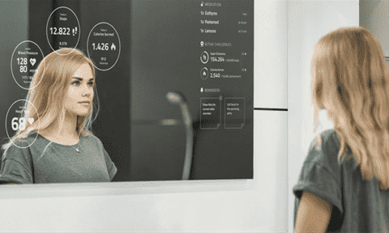
Figure 18. Picture which describes a mirror used as screen
External connections:
a) UWB wireless communication technology, which includes wireless communication and positioning functions. It has high data transmission rate and well-performed security. Users can find nearby users quickly.
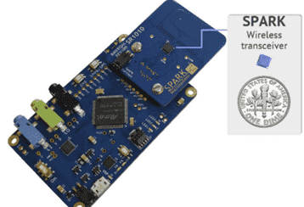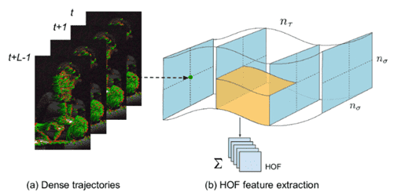
Figure 19. inner structure of UWB (left) and working theorem of dense trajectory analysis (right)
Body monitoring:
a) Machine learning combined with the image recognition based on CNN.
b) Dense trajectory analysis, which is to conduct intensive sampling for the live video, track the sampled points to obtain the trajectory, and then do the behaviour recognition with extracting the characteristics of the trajectory.
Personalized customization:
a) Collaborative Filtering, which can use the user's historical selection information and similarity relationship, collect the evaluation information of other users with the same interests and hobbies to generate recommendations.
b) Mining of spatial association rules based on Apriori algorithm.
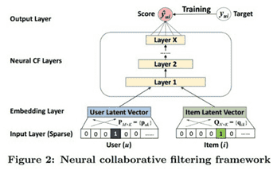
Figure 20. Working theorem of neural collaborative filtering framework

Step4: Explore systematically
In this step, we combined both existing and new sub-problem solutions, which could be combined into overall solutions.
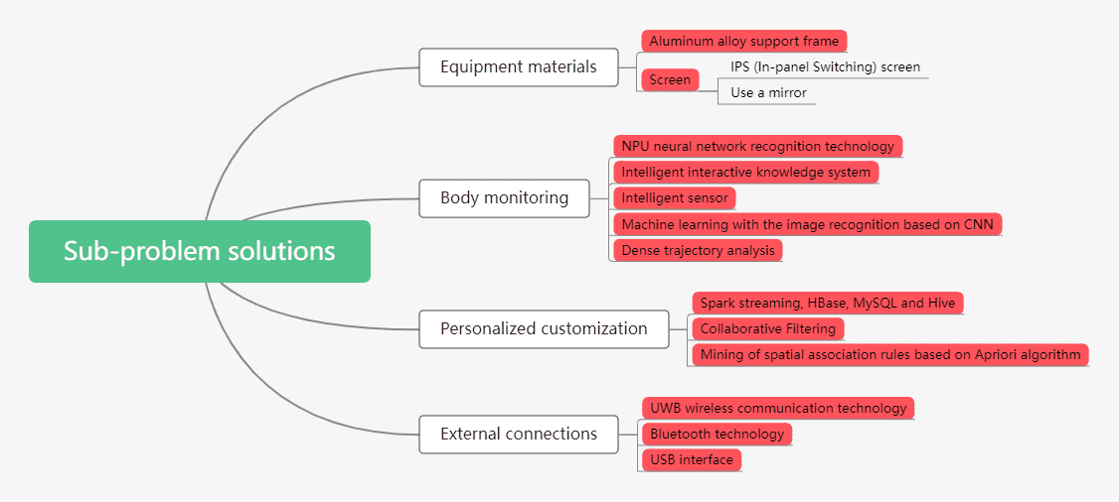
Figure 21. collected solutions of sub-problems

Step5: Reflect on the solutions and process
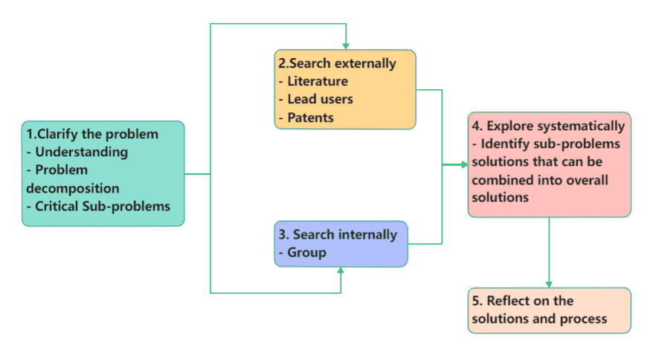
Figure 22. The whole stages about concept generation
After the above steps, we thought this intelligent fitness device was feasible. Firstly, we discussed the functions of the product and decomposed problems, so as to get critical sub-problems. Then, we further investigated the comments of leading users, learned about the analysis of existing concepts by literature, and searched patents to obtain the latest information. In addition, our internal group members made further thinking and obtained the solution of the sub-problems after comprehensive consideration. Therefore, we had reasons to think that we had come to the complete concepts.

Concept Testing

Step1: Define the purpose of the concept test
We made this test for three purposes. The first purpose is to improve product functions to better meet customer needs. The second purpose is to improve the cost performance of products and suitably reduce the price of products to win the market. The third purpose is to seek cooperation with companies who produce small fitness equipment.

Step2: Choose a survey population
In order to draw a referential conclusion, we chose a specific survey population. After our analysis, we believed that the amateur fitness enthusiasts, and people who trusted technology and were fond of technology, would be more interested in our products. So they were chosen for survey.

Step3: Choose a survey format
Under the influence of the COVID-19, our face-to-face talking was replaced by talking on WeChat and online meeting. Besides, we chose to send a survey on the website, which allowed different people of different jobs to comment. We collected information via an online questionnaire.
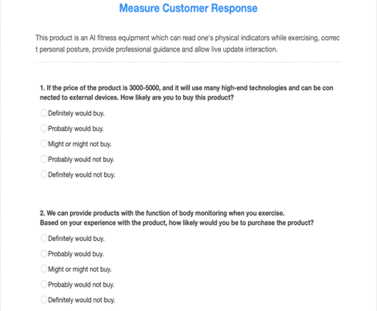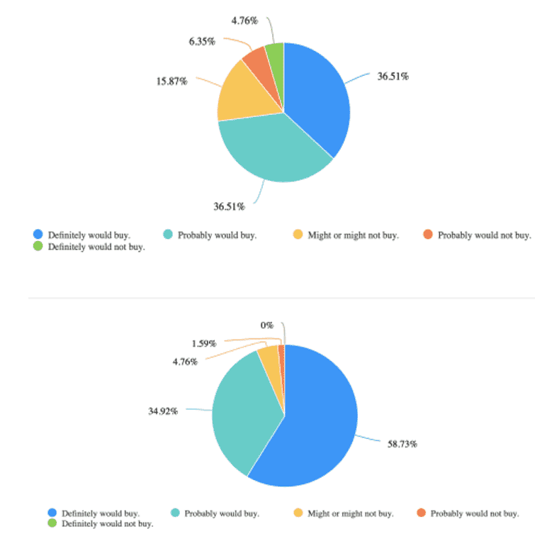
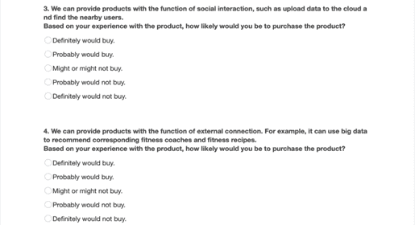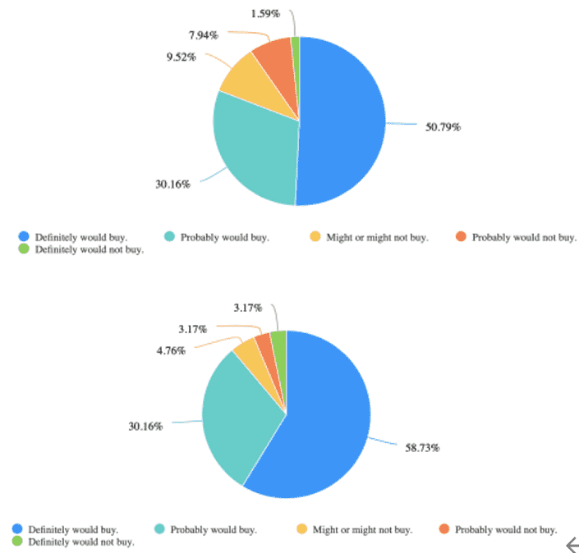
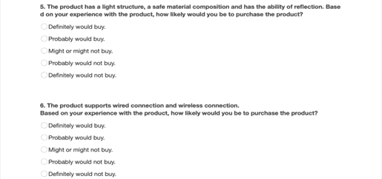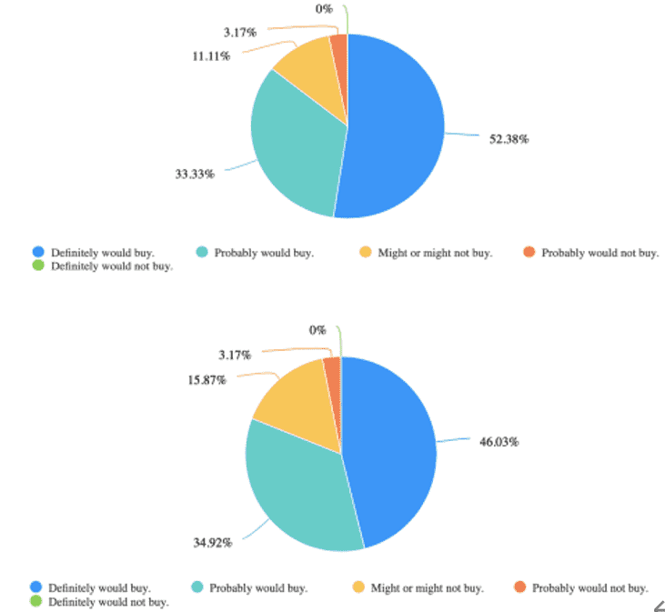
Figure 23. Questions of the questionnaire and customers’ response

Step4: Communicate the concept
Drawing:
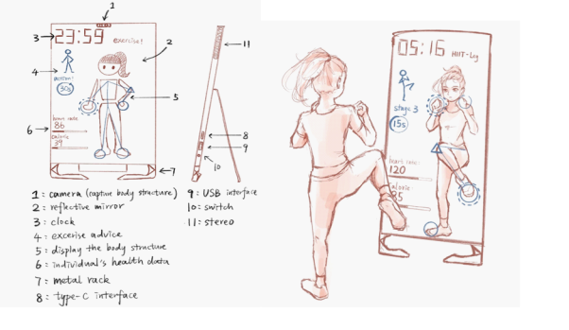
Figure 24. Drawings of our product’s concept
Verbal description
An AI fitness equipment which can read one's physical indicators while exercising, correct personal posture, provide professional guidance and allow live update interaction. These functions can be realized by many technologies, such as NPU neural network recognition technology, UWB wireless communication technology, dense trajectory analysis and so on.

Step5: Measure customer response
According to the results of the above questionnaire, we could draw the following conclusions：
- Customers want the product to have the function of body monitoring and external equipment connection most.
- When customers buy products, they have the highest requirements with the price. Because 4.17% of survey users said that a slightly higher price would lead to their lower purchase intention.

Step6: Interpret the results
From the graphs above, we could conclude that the target customers were very interested in our products. They wanted to buy a sleek, portable fitness device which had functions like motion sensing, online social networking and so on. So we had reasons to believe that our product’s concept met the customers’ needs well.

Step7: Reflect on the results and process
After completing the reflection and summary of the whole process, we could draw the following conclusions. First, we had collected the opinions of target users extensively on the Internet. Secondly, our products had great potentials, and the vast majority of people we surveyed had shown great purchase intention. Finally, our products used big data, deep learning and other high-tech technologies, which could basically realize our planned functions like online social interaction, motion sensing detection and so on. Therefore, we could say that our products would get great support in the target market.
Conclusion

Finding
In this report, we finally decided to launch a product: An AI fitness equipment having characteristics of body monitoring, social interaction, personalized recommendations and external connections.
Firstly, our group used the Ulrich and Eppinger’s six-steps process to identify four product opportunities. After utilizing the R-W-W framework, we finally selected “AI fitness equipment” as the exceptional opportunity. Then, when our group had the second meeting, we accomplished the mission statement, making business goals and decided on the primary and secondary markets.
Moreover, we collected the customers’ needs by delivering questionnaires. Not only did we organize the needs into a hierarchy, but also we established the relative importance of the needs, so as to make the potential users more satisfied in the future.
In the next step of concept generation, we separated the problems into sub-problems, and using external and internal research to find out solutions of critical sub-problems. For example, we could use the NPU neural network recognition technology to realize body monitoring. After exploring systematically, we made complete concept frames and did concept testing using questionnaires.
In a word, after finding deeply, we got a conclusion that the AI fitness equipment could have big market shares and satisfied our customers in the future.

Potential
- Huge potential market
Our products involve fitness trainers and nutritionists, so we can better cooperate with some experts in these areas. Meanwhile, we can also build concrete relationship with fitness apps such as Keep. We can also expand our cooperation with some outdoor gyms.
In addition, our fitness equipment can make collaborations with high-tech companies, so that the current sports bracelets on the market can be connected to our products.
Due to the high possibilities in the current market, we can attract more investment and financing institutions.
- Sustainable development
Our fitness product is built on a lot of new technologies like artificial intelligence and deep learning, so we can continue to attract young talents to our company. By this way, we can achieve sustainable development and let our product keep pace with the times. At the same time, our product may be supported and promoted by the government.

Shortcomings:
- The cost is too high
The function of our product determines that its price will not be very cheap, which may lead to uneven market share, that is, a large number of low-income people may not be interested in buying the product.
- Lack of marketing experience
At present, there are few precedent products that can be used for reference in China. Consequently, the follow-up development may encounter unknown risks.

List of References

- Li, F. (2021) Personalized e-commerce recommendation system based on user history behaviour sequence. 11(33), 59-62. Available from: doi: 10.19981/ j.cn23-1581 /G3.2021.33.014
- Li, S. & Zhao, C. (2001) Introduction and prospect of Bluetooth technology. China data Communications. (11), 30-32. Available from: https://www.cnki.com.cn/Article/CJFDTOTAL-TXWL200111008.htm [Accessed 20th April 2022]

Coursework Meeting Logbook

Members of the Team
Role | Given Name | Family name | BUPT number | QMUL number | Class Number
Leader | Tangxun | Wu | 2020213248 | 200978947 | 2020215107
Member | Ruiqiao | Yang | 2020213249 | 200979287 | 2020215107
Member | Yurong | He | 2020213242 | 200977331 | 2020215107
Member | Wenxi | Han | 2020213246 | 200977283 | 2020215107
Member | Zihe | Wei | 2020213281 | 200978866 | 2020215108
Project Title | An AI Fitness Equipment
Date: 13-03-2022
Meeting type: Online meeting
Topics Discussed: We discussed what kind of product we wanted to build using opportunity identification and identified what we needed to submit to QMPlus.
Tasks to be achieved by next meeting: Make the project mission statement, finding target markets.
Next meeting (date/time): 20-03-2022

Date: 20-03-2022
Meeting type: Online meeting
Topics Discussed: We have completed the pre-project plan and made the project mission statement, including product description, key business goals, primary market, secondary markets, assumptions & constraints and stakeholders.
Tasks to be achieved by next meeting: We will discuss the concept development and determine the customer's needs in five steps.
Next meeting(date/time): 26-3-2022

Date: 26-03-2022
Meeting type: Online meeting
Topics Discussed: A brainstorm about what functions our product should meet and start to analyze the customer needs.
Tasks to be achieved by next meeting: Collect the results of our questionnaire about identifying customer needs and analyze the findings.
Next meeting (date/time): 02-04-2022

Date: 02-04-2022
Meeting type: Online meeting
Topics Discussed: Analyzing the findings on questionnaires and compiling the customer needs.
Tasks to be achieved by next meeting: Complete the concept generation by steps.
Next meeting (date/time): 14-04-2022

Date: 14-04-2022
Meeting type: Online meeting
Topics Discussed: Concept generation steps of our product, Search internally to find solutions about critical sub-problems about our product.
Tasks to be achieved by next meeting: Have a discussion about how to accomplish concept testing and make a conclusion about this report.
Next meeting (date/time): 24-04-2022

Date: 24-04-2022
Meeting type: Online meeting
Topics Discussed: We discussed the ideas to complete the testing and conclusion and divided testing into seven steps and conclusion into three parts. Everyone got a clear task.
Tasks to be achieved by next meeting: Check about the whole report together.
Next meeting (date/time): 07-05-2022

Date: 07-05-2022
Meeting type: Online meeting
Topics Discussed: Check for the report errors together.
Tasks to be achieved by next meeting: Prepare for the video presentation.
Next meeting (date/time): 14-05-2022

